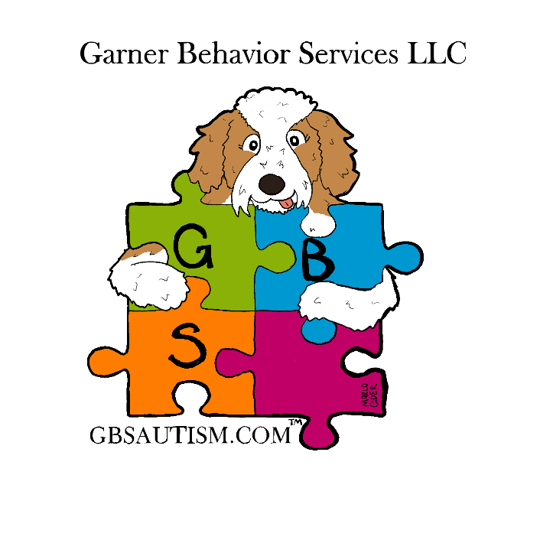
GBS Quality Assurance Report

February 2025 – September 2025

At GBS (Garner Behavior Services), it is our mission to provide a fun, engaging, therapeutic environment for children with autism to thrive, grow and expand their independence in addition to supporting families and providing community outreach programs.

Overview

This report summarizes the quality assurance data collected from February 2025 through September 2025 demonstrating the quality, timeliness and appropriateness of services.
The data reported here was collected in various formats including direct observation, record reviews and surveys. GBS QA Report is available to consumers upon request as noted in the Service Agreement reviewed and signed by caregivers yearly.

Record Review

Record review is conducted bi-monthly on 70-100% of clients via GBS Internal Audit Form. Record review is conducted by Administrative Staff or Technicians trained to complete the Internal Audit Form and who are familiar with client records.

Assessment of Outcomes of Services

There were 26 clients receiving services at GBS during the time specified.
From February 2025 to September 2025, the average number of ITP goals completed per client is 2.8 with some clients completing as many as 18 goals over the time specified in this report.

For the 6 clients discharged during the time specified, GBS noted recommendations for the parents to contact and agencies were listed for continued treatment for the remediation of deficits due to the diagnosis of ASD. The discharge summaries were completed within 14 calendar days of the last face to face treatment contact.

Compliance with Service Description

Ways in which GBS adheres to the details of the Service description include but are not limited to:
  - Limiting the number of clients served at each center to a maximum of 25.
  - GBS ensures that all center-based services are medically prescribed and recommended via a written order and that each written order is renewed yearly.
  - GBS incorporates facilitated play into 100% of daily sessions for all clients, all clients are prompted and reinforced based on their specific goals as noted in their individual treatment plans, and every aspect of center-based activities are communication based as told in the description of center-based services.
  - GBS ensures that data is collected on each treatment plan goal, current targets, response to interventions, behavior frequency and graphed for visual analysis per the description of progress monitoring.
  - GBS recorded one instance of restrictive procedures being used during the period covered by this report. This action was deemed necessary and was carried out by the on-site Safety Care Specialist. All protocols for the safe use of restrictive procedures were followed, including, but not limited to, the use of de-escalation techniques, which were unsuccessful. The client was determined to be a danger to themselves or others, prompting the intervention. Additionally, a post-intervention debrief with the staff involved was conducted by a supervisor.

GBS complies with the current IBHS Service Description.

Method of Record Review

Sample Size: GBS Internal Audit Form is conducted on 70-100% of current clients monthly to ensure compliance with IBHS regulations.
Frequency of Review: Monthly, quarterly and yearly. GBS Internal Audit Form attached for review.
Reviewer Qualifications: Reviewers of records are administrative staff or technicians who are familiar with client records and who have been trained in GBS Internal Audit Form.

Consumer Satisfaction Survey Results

GBS aims to ensure that clients, their families, and all consumers of GBS services are satisfied with the quality of the therapeutic services their child receives, interactions with GBS staff, and the overall experience with GBS. GBS invites all clients/parents to complete satisfaction surveys annually. GBS director or Designee will review satisfaction surveys to provide feedback to employees and improve services. Five responses to the parent/caregiver survey were gathered.
The survey consisted of 42 questions. The first four questions involved demographics and the last three involved open comments from the caregivers.
Demographics:
80% of clients have been attending GBS for 6-12 months.
40% of clients started therapy at GBS at 3 yrs. of age.
The two most common alternate therapies GBS clients receive are SLP and OT.
80% of families have a history of ASD within the family.

The remainder of the survey included questions about the client’s behaviors and parent satisfaction. A 5-point scale was used to collect responses, ranging from 1 (lowest/not at all) to 5 (highest/frequently). The overall scores were 3 & 4 (average/high) with 100% of participants scoring 4 (high) for the following:
Question | Average Rating
My child appears to enjoy attending sessions at GBS | 4.6
Since attending GBS, my child’s comprehension of words and simple phrases has increased. | 4.2
Since attending GBS, my child is making more eye contact as a means of communication. | 4.4
The overall quality of our family’s interactions with my child has improved | 4.4
I feel like I understand why my child is learning the skills they are learning | 4.4
I receive regular updates on my child's progress (every 6 months at least unless requested) | 4.8
I am happy with how my questions are responded to/addressed by GBS staff | 4.6
I feel safe leaving my child at GBS Therapy Center | 5.0
My parenting skills have improved | 4.2
I feel the therapy my child is receiving is making a meaningful impact on my child’s progress. | 4.8
I feel I receive adequate attention from GBS staff | 4.6
GBS staff are open to scheduling appointments to meet with me when I contact my child's BC-ABA to schedule an appointment | 4.8
I feel my concerns are heard | 4.8
I feel the staff at GBS are highly qualified and highly trained | 4.8
I feel I am a part of my child's therapeutic team | 4.6
GBS staff act and present as professionals | 5.0
GBS staff are knowledgeable about ABA and behavior management | 5.0
My child's BC-ABA provides me with strategies to help me manage my child's behavior at home | 4.6
GBS staff are collaborative with the alternate therapies my child attends | 4.6
GBS staff respect my culture and family values | 5.0
Overall, I am satisfied with GBS Therapy Center | 4.8
I feel my child has made greater progress towards goals due to being in a center-based program | 4.4

Survey items scoring less than 4.0 included:
Item | Average Rating
I would like my child to receive more hours of ABA therapy | 1.4
I wish my child only received services in home and did not have to attend center-based services | 1.0
My child would make more progress if they had additional hours of therapy in home | 2.2
I feel like I am more versed in ABA now than I was before my child started therapy at GBS | 3.8
Since attending GBS, my child is engaging in more appropriate toy play | 3.6
Since attending GBS, my child is more aware of others in his/her environment | 3.4
Since attending GBS, my child's vocabulary (pictures, vocal, VOD) has increased. | 3.89
Since attending GBS, I can understand more of my child's spoken language | 3.44
Since attending GBS, my child has increased initiating interaction with peers | 3.2
Since attending GBS, my child appears to be less frustrated | 3.8
Since attending GBS, my child appears more focused on activities and is able to stay with a task for longer periods of time | 3.6
Since attending GBS, my child's self-help skills have improved (toileting, eating, dressing, etc. | 3.0

Open ended Survey Questions:

In response to the prompt, “I feel GBS is very good at...”

“Communication on a daily basis with food logs and soap notes”

“Being flexible for frequent medical appointments”

“Socializing my child”

“Communicating with parents and caregivers in regard to progress/change in the plan of care. RBTs and BCBAs are welcoming. Specialists are well trained.”

“Being kind, fun, and welcoming. My child has been thriving from the routine at the center, making it easier for us to practice skills at home!”

In response to the prompt, “I feel GBS could improve...”

“By knowing staff more. Maybe include pictures and names in a blurb in the newsletter or something”

“Wish we had a closer location”

“I have no suggestions. I am truly pleased with the center in general and all the staff that work with my child”

“Skills and knowledge in prevention of sensory/demand overloads in young children that can lead to autistic meltdowns. Implementing knowledge of gestalts language processing in autistic children.”

Results of the GBS Caregiver Survey indicate GBS is providing a service families are satisfied with receiving. GBS will continue soliciting feedback from caregivers to improve and modify services and to improve caregiver satisfaction.
Parent Notification of QA Report

The Service agreement signed by parent/caregiver at intake and reviewed yearly states:
4. Quality Assurance As a parent/caregiver, I understand and agree that:
a. I will truthfully complete an anonymous annual quality assurance survey for
GBS services my child receives.
b. GBS Annual Report will be available in September of each year upon request.
Parents/caregivers will be notified of annual satisfaction survey results and GBS will provide an electronic copy of the survey results upon request.

Additional Information

Client Gender
- 20% female
- 80% male

Client age at intake:

Location of Service:

13% received telehealth only
20% Lock Haven Location
33% Lewisburg Location
33% Williamsport Location

Client diagnosis:
GBS provides services to children with autism spectrum disorder diagnosis.

Report Analysis

The GBS Quality Assurance Report for February 2025 to September 2025 indicates GBS has met caregiver satisfaction, has provided a quality service to our consumers, and provides an appropriate service. A review of records indicated an increase in acquired goals over the past year.
Action Plan

To ensure continued quality of services at GBS, we plan to continue the following actions:
- Yearly consumer satisfaction survey
- Yearly employee satisfaction survey
- Internal Audit Form for Client Records
- Compliance with IBHS Regulations
- Compliance with Insurance Regulations

In addition, we plan on the following:
- Review of updated IBHS regulations
  - Administrative staff have begun to review all IBHS regulations to ensure GBS is within regulations.
- Participation in local CCBH and IBHS provider meetings
  - Increased collaboration with area providers to our consumers
  - Increase in home hours for center-based clients.
  - Implementation of parent training by clinicians as group and individual meetings

- Continued revision and improvement of employee onboarding process and training
  - Continued revision and improvement of caregiver and community outreach programs
- Addition of client bios and pictures in quarterly newsletter

For any further questions or comments regarding Garner Behavior Services Quality Assurance Report, please contact: drgarner@gbsautism.com

Submitted: 10-7-25 DG

